Project Proposal

ALY 6980 21311 Capstone SEC 02 Winter 2019 CPS

Instructor: Alice Mello

Liang Shi

03/28/2019

**Introduction**

Project proposal is the social effect which can be suggested for PUMA to make based on its brand and certain research results. In this project, the project proposal would be ‘Use Brand Effect to Help Startups Develop’. According to the PUMA 2016 annual report, PUMA’s products mainly focus on soccer, running and training, golf and motorsport. So the project proposal is suggesting PUMA to help startups who specialize on fashionable or delicate-designed clothing, to develop because those are items that PUMA does not focus on, then PUMA could sell the products of startups on their stores for a small commission.

The ration behind this proposal is based on the harm of monopoly in this industry because customers deserve to have more options when making purchase. Competence can motivate companies to innovate and keep improving their technology, even for the big names is the same, and ultimately the customers will benefit. Thus, Puma’s behavior based on its brand effect will cause the whole industry to develop in a right way.

**Literature Review**

For the first literature, which is ‘Forecasting Production Quantity by Integrating Time Series Forecast Technologies and Artificial Intelligence Method'. The purpose of this article is to help a massage chair part company to assess order quantity, which is the output result. It can be stored in a time series, and at the same time, this variable will be affected by several factors including price, location and etc. In terms of traditional time series forecast, moving average and exponential smoothing are commonly used, while most of the methods consider only previous quantities without considering other affecting factors, thus here comes the importance of artificial neural network and fuzzy neural network(Fengming, 2016). By calculating the root mean squared error of each model combo, the final conclusion is that integrated moving ANN and integrated moving FNN has the best forecast results with the least error.

An obvious advantage of this literature is that it explained each method clearly, besides, the idea of combing different methods to see the forecast accuracy is innovative. What's more, the author use a 3D plot to visualize the comparison between root mean squared error which is pretty straight forward. Generally speaking, this article can be of great help to my work in puma case. However, some specific explanations about how the neural network is integrated with time series is missing in this literature, it merely provided a general theory and jump into the conclusion which is better. It would be better if the author can explain the principle of combination more in detail.

For the second literature, which is ‘Managing uncertainty through supply chain flexibility: reactive vs. proactive approaches’. The author talked about the uncertainty model in a more theoretical way by classifying strategies to improve supply chain flexibility and the pertinent objectives, along with four case studies to better explain. Besides, there are three main propositions need to be further tested. The first one is companies tend to use reactive rather than proactive strategies, it is understandable because reactive strategies are easier to carry out. The second one is companies seem to be more inward than outward-looking when there is a need to higher flexibility. The last one is companies tend to work more on their internal systems(Reina & Nyoman, 2013, pp.50-70).

The comparison between two strategies was clearly explained in this literature, author still hasn’t solved the question raised in the article that, when should we use which one. Most of the points were illustrated in a conceptual way, so some quantitative testification might be needed.

For the third literature, which is ‘Time series forecasting using a hybrid ARIMA and neural network model ', it mainly talked about ARIMA model and artificial intelligence neural network. The popularity of the ARIMA model is due to its statistical properties as well as the well-known Box-Jenkins methodology in the model building process(G.Peter, 2001). The most important idea of this literature is that it illustrated the functions and orders of these two models clearly.

While even this literature solved my confusion about how exactly these two models work together to improve the accuracy, one critique for this literature is that the information about how to decide on the layers and nodes of an ANN model is missing. It cannot be denied that it is an issue of experimenting to find the best result, while there should still be some objective rules that we can turn to.

For the fourth literature, which is ‘Online ARIMA Algorithms for Time Series Prediction’. This literature mainly talked about the model optimization based on two innovative online ARIMA algorithm which are ARIMA Online Newton Step and ARIMA Online Gradient Descent. These two algorithms satisfy the q-th order difference equation with the absolute value of coefficient βi, as well as minimize the loss function. By utilizing the new algorithms with both synthetic data and real data, the efficiency was validated.

This literature proposed a smart way to optimize ARIMA model, and it partially solved the historic problem about how to decide the order of ARIMA parameters. While it lacked the comparison between these two algorithms, as well as the explanation for when to use which one.

For the fifth literature, which is ‘Small firm-large firm relationships and the implications for small firm innovation: what do we know?’. It mainly talked about two kinds of relationships which are vertical relationship and horizontal relationship. The components and innovative methods of these two relationships are different, before cooperating with each other, both sides should be clear with their roles(Andrew, Sally, James, Stephen& Jack, 2014) .

Even it is such a clear literature in elaborating how the large firms can help small firms to develop, the author left a question unsolved about what role should the small firms play after large firms reach out to help and what small companies should do to make the positive effects long lasting.

Research Method

To make the project proposal more persuasive, mix methods were used during the research. The basic definition of mixed methods is the combination of both qualitative and quantitative research. The problems addressed by social and health science researchers are complex and the use of either quantitative or qualitative approaches is inadequate to illustrate the complexity. To better definite the mix methods research, qualitative and quantitative parts will be approached separately.

The reason for using both approaches is that only quantitative method is inadequate to illustrate and realize the business intelligence behind the model. In PUMA case, it is true that we can construct models and make forecast based on quantitative data, while the data cannot reflect the social effects. For example, to realize the proposal, we have to investigate the social influence of PUMA in the sports industry, whether the other sports start-ups are willing to adapt the forecast model of PUMA, etc.

‘At once’ dataset given by PUMA is the main dataset used in the research. It is a text file which contains most of the information about one transaction record, including the sales type, market channel, order requested date, the date that order was entered into the system, product division, product classification, gender purchased, net dollar values, requested quantity, shipped quantity and cancelled. Among all the variables, the most important ones are the date and business indicators including net dollar values and several quantities, since all transaction records happen in the same time, the only variable we can reply on is date. What’s more, the start date matters because normally a company will prepare the shipment once customers require the order. Simultaneously, order quantity will be taken as the representation of ‘at once business’ because it can really help PUMA to make preparations for this kind of business and it is the purpose of constructing this predictive model.

**Result**

Just as mentioned before, the only affecting factor is date, so basically time series predictive model will be used. This model works for project proposal because when selling the sport clothing, Puma will also meet the ‘at once’ problems, so the time series prediction model can help Puma better prepare its products in advance.

The model used to predict the time series data is ARIMA model which stands for auto regressive integrated moving average, but before that, we have to get an overview of the data by visualizing it.

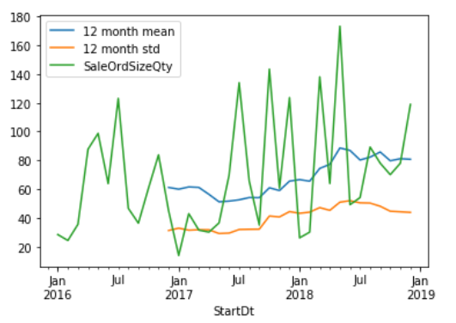

Figure1

According to the plot, the sales order quantity fluctuated a lot cross time. One thing to keep in mind is that before using ARIMA, we have to make sure the time series data is stationary which means the mean, standard deviation and auto correlation structure do not change over time. Obviously, the mean and standard deviation just change slightly and they do not necessarily have a time pattern. To double check the stationarity, adfuller test is also needed. The null hypothesis of adfuller test is that time series is non-stationary and the P value is further smaller than 0.05, so we can reject the null hypothesis and confirm our time series data is stationary.

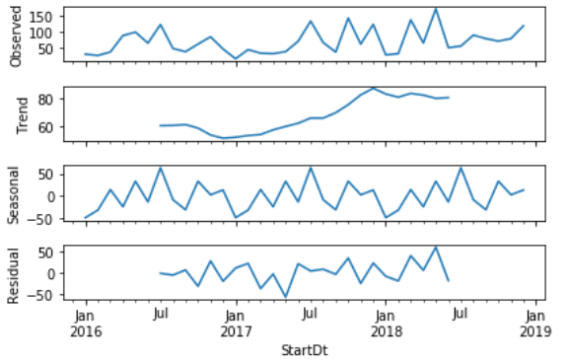

Figure2

By decomposing the data, we can get to know the trend of the sales order quantity of all ‘at once’ sales, as well as the pattern of its seasonality and residuals. This step also enables the audience to have an overview of our data and make preparations for prediction.

To build and test model, dataset was into train set and test set by 70% and 30%. As the result shows, the mean squared error is only 2462.651 which is relatively a good result . To be more clear with the comparison between prediction and observed data, the result is also visualized

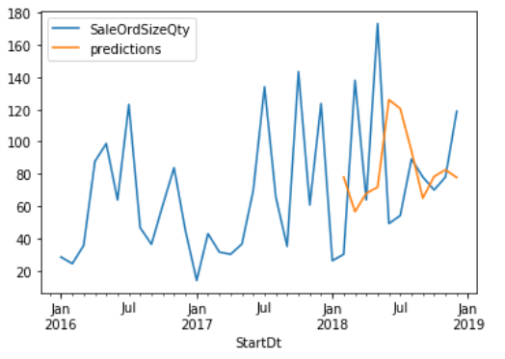

Figure3

**Conclusion**

According to existing result, this ARIMA model is pretty good in forecasting at once business condition since the error is small. This model can help PUMA in forecasting the next month's order quantity which can give PUMA an overview of how many products should be produced in advance just in case the at once orders happen. Once this model is tested, PUMA can pass the model to start ups.

To be more specific, we can try to imagine a fictious start up which mainly selling customized sports hoody. As we know, customized products can take a lot of time to design so the in-advance reservation is extremely important. Since the time lag was set as 1 in the prediction model, which means normally the user can predict one month’s at once business based on last month. This start up can take advantage of this prediction model according to its specific demand by changing the parameter of p to determine how many time lags to be used in prediction. This model can really benefit the start up because it solves a common problem for start ups that there is insufficient historical data for self-constructing and testing a models. Since PUMA is such a big company, an obvious advantage is that the volume of data could be higher and the result could be more accurate.

**Reference**

Chang, F. (2016). “Forecasting Production Quantity by Integrating Time Series Forecast Technologies and Artificial Intelligence Methods”. Proceedings of the The 3rd Multidisciplinary International Social Networks Conference on

Socialinformatics 2016, Data Science 2016, 1-5.

Reina Angkiriwang, I Nyoman Pujawan & Budi Santosa (2014) “Managing uncertainty through supply chain flexibility: reactive vs. proactive approaches”.

Production & Manufacturing Research, 2:1, 50-70, DOI: 10.1080/21693277.2014.882804 .

G. Peter,Z (2001, November 23). “Time Series Forecasting Using a Hybrid ARIMA and Neural Network Model”.

Neurocomputing 50 (2003) 159-175

Chenghao. L, Steven C. H, Peilin. Z & Jianling.S. “Online ARIMA Algorithms for Time Series Prediction”. Proceeding of the Thirtieth AAAI Conference on

Artificial Intelligence (AAAI – 16) 1867 -1873

Andrew. J, Sally.G, James H. L, Stephen. R and Jack.W (2014, June). “Small Firem-Large Firm Relationships and the Implications for Small Firm Innovation: What Do We Know?”.

ERC White Paper No.9